TEAM – 18

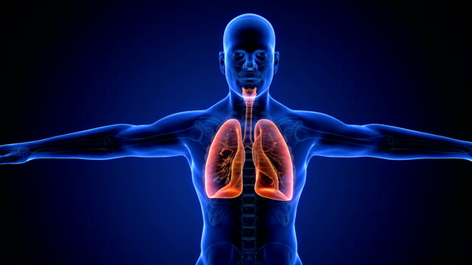

’ 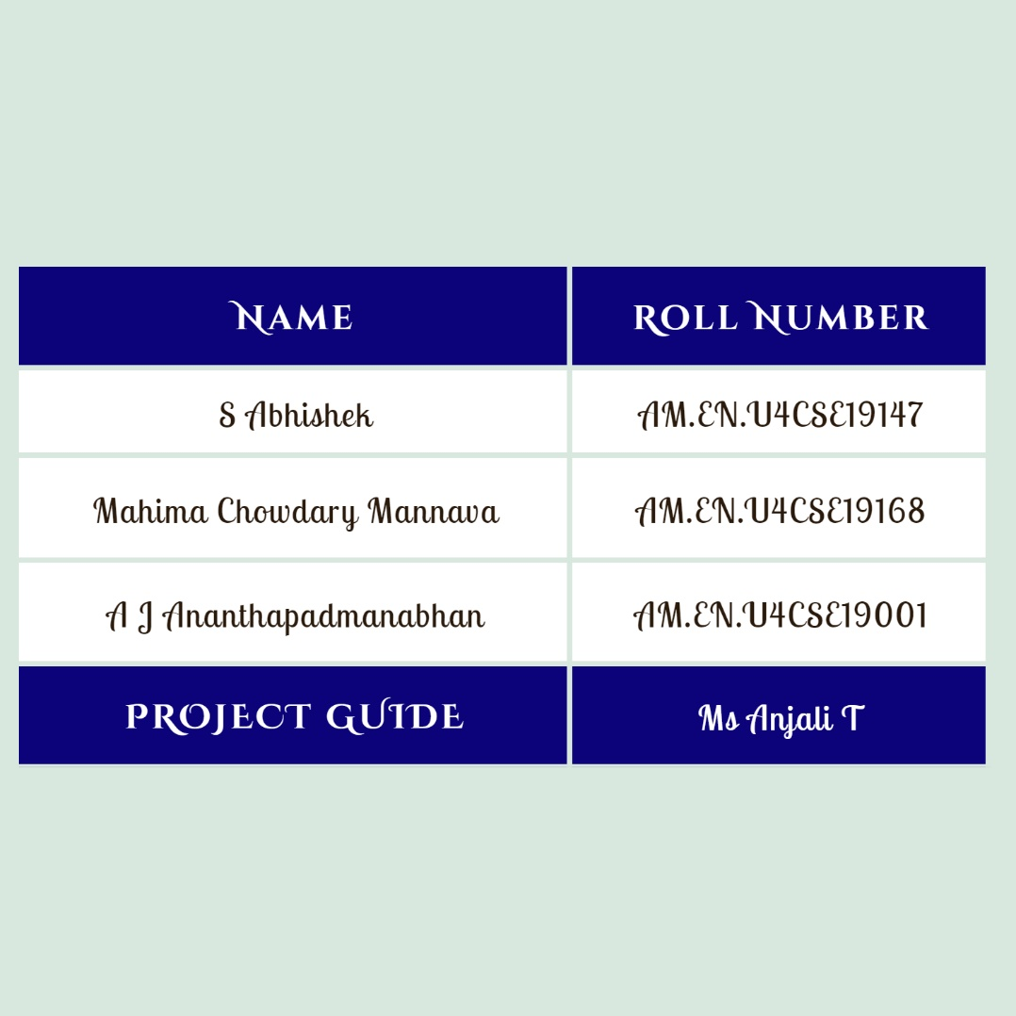

AUSCULATION SOUND CLASSIFICATION

TEAM DETAILS

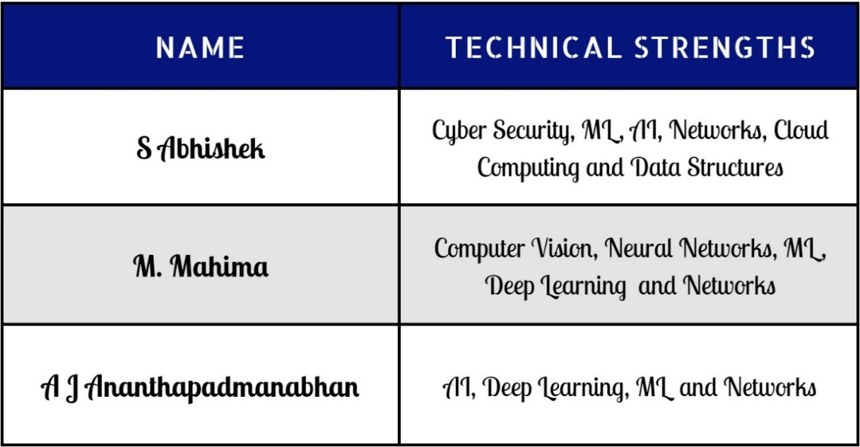

* Motivation and Objective

Auscultation has been an essential part of the physical examination; this is non-invasive, real-time, and very informative. Essential indications of pulmonary health and diseases are respiratory sounds. The sound a person makes when they breathe directly correlates to the flow of air, changes in lung tissue, and the location of secretions inside the lung. One typical indicator that a patient has an obstructive airway illness, such as asthma or chronic obstructive pulmonary disease, is wheezing (COPD). To diagnose respiratory disorders and administer first aid, it's crucial to listen for unusual breathing sounds with a stethoscope. In this project we will be creating an automated categorization of breath sounds to get around these restrictions where we classify different respiratory noises (usual crackles, wheezes, and rhonchi) collected in the clinical context using deep learning techniques.

* Problem Definition

Chronic obstructive pulmonary disease (COPD) is India's second-leading cause of death. It accounts for nearly 13% of all deaths, according to the Global Burden of Disease study survey published by Washington University in 2018. There are commonly two methods used to diagnose respiratory illnesses. The first method makes use of data from the patient's underlying illness and imaging tools (such computed tomography and magnetic resonance imaging). Face-to-face evaluations are difficult to undertake in a circumstance like the present epidemic, and these tests cost time and money. The second important factor is the use of a stethoscope in the diagnosis and first assistance of respiratory diseases.

In this project we will be developing a system using deep learning techniques combined with chest auscultation that accurately classifies lung dysfunction where we create a prediction model that combines respiratory sound, a set of pre-trained picture feature extractors, and classifiers.

* Strategic Plan

We begin by stating our immediate and long-term goals, which for the time being, are to notice the relationships between the collected dataset's attribute values. Considerations include patient number, recording index, chest location, acquisition method, and recording apparatus. Then, using specific techniques and procedures, we may finalize the process of data mining from a database which entails either discovering the pattern in the provided data, known as the training sample or analysing a group of items that have previously been categorized, whose findings may be used to forecast the outcomes of further data with missing characteristics, known as the test sample. Any potential issues with the work will be carefully reviewed, and any problems will be resolved using an updated algorithm or better model.

Project Phase I (Minor)

* The project's first phase's goal is to read patient metadata and infer any missing values where we will import audio file annotations (which contain information on the number of crackles and wheezes identified, as annotated by people), read in audio data (.wav files), and illustrate the distributions of patient metadata (STFT and IRCC).
* Integrating audio annotations and patient details into a single large data frame is the next crucial step (one record per audio file) and the datasets will be divided into train and test sets to keep track of the audio file and maintain alignment between the two inputs.
* Finally, we may design a multi-class decision tree method to categorise illnesses by utilizing the annotation files that contain data on the number of crackles and wheezes in each recording.

Project Phase II (Major)

* The objective of the project's second phase is to execute several categorization algorithms and CNN utilizing the STFT (inputs are the STFT), Boosted Decision Tree using XGBoost (inputs are the combined metadata and annotations), Logistic Regression (inputs are the integrated metadata and annotations), and Neural Network concatenating a CNN (inputs are the STFT) and a Deep Neural Network (inputs are the combined metadata and annotations).
* Given the significant imbalance in the data set, we will use standard assessment criteria for each test, focusing more on precision and recall than accuracy.
* Drafting, Revising and submission of final project report.
* Dataset
* Two research groups in Greece and Portugal developed the Respiratory Sound Database. It has 920 recordings with annotations, ranging in duration from 10 to 90 seconds. These recordings came from 126 different patients.
* A total of 5.5 hours of recordings comprise 6898 respiratory cycles, of which 506 have wheezes and crackles. Of these, 1864 respiratory cycles have crackles, 886 have wheezes, and 1864 have both.
* The data consists of recordings of both clear respiratory sounds and noisy ones that reflect actual environmental circumstances. Children, adults, and senior citizens are all represented among the patients.
* Software Tools and Packages
* Jupyter Notebook/Google Colab
* Python >= 3.6
* Publication Target
* Scopus (End of February)



**Project Mentor - Ms Anjali T**

Assistant Professor, Department of Computer Science & Engineering

[Amrita Vishwa Vidyapeetham](https://scholar.google.com/citations?view_op=view_org&hl=en&org=1628360162380345289), Amritapuri, India